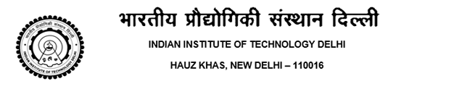

No.: IITD/UGS(Bon-Cert)/2018 Date: 27/04/2018

# CERTIFICATE

This is to certify that Mr. NAME Entry No. 2015CEXXXXX S/o Mr. FATHER’S NAME and Mrs. MOTHER’S NAME is a bonafide student of the 4-year B.Tech. programme in Civil Engineering during the academic year 2017-2018 at this Institute.

This certificate is being issued to the student at his own request for submission to BOSCH LIMITED, GURGAON for Self Arranged Internship.

## Supdt./ Asstt.Registrar (UGS)